

**SCHOOL VALUE DATA ANALYSIS**

Group 6

Names : Dhayu Wiragusti

Muhammad Kara Maritza

Vittorio Abdel Azis

Class : 1CC5

**CEP CCIT**

**FACULTY OF ENGINEERING UNIVERSITY OF INDONESIA**

**2022**

# **PREFACE**

All praise is due to Allah for giving us the patience and capability necessary to finish this project on time with a title “School Value Data Analysis”. We would like to express our gratitude to our parents who always support us in all conditions and also, we would like to thank Mr. Tirta Akdi Toma Mesoya Hulu S.Kom. as our supervisor who always helps us to finish this paper.

This paper was prepared to fulfil our project assignment as CEP CCIT FTUI students. The topic that will be discussed in this paper is analysis data on grades at a school. We hope this paper will be beneficial to all those who read, especially in education of information technology.

The author realizes that this paper is far from perfect, so it will be very helpful if colleagues and supervisors are willing to provide suggestions and criticism for the perfection of this paper.

# **TABLE OF CONTENT**

**PREFACE** i

**TABLE OF CONTENT** ii

**TABLE OF FIGURES** iii

**TABLE OF TABLES** iv

**CHAPTER I** 1

**I.1 Background** 1

**I.2 Writing Objective** 1

**I.3 Problem Domain** 1

**I.4 Writing Methodology** 1

**I.5 Writing Framework** 2

**CHAPTER II** 3

**II.1 Microsoft Excel** 3

**II.2 Data Tables** 3

**II.3 Table Functions** 6

**CHAPTER III** 12

**III.1 Conclusion** 12

**III.2 Suggestion** 12

**BIBLIOGRAPHY** 13

# **TABLE OF FIGURES**

**Figure 2. 1 Sort and Filter Science Student Grades** 6

**Figure 2. 2 Sort and Filter Social Student Grades** 6

**Figure 2. 3 VLOOKUP Science Student Grades** 6

**Figure 2. 4 VLOOKUP Social Student Grade** 7

**Figure 2. 5 AVERAGE Function Science Student Grades** 7

**Figure 2. 6 AVERAGE Function Social Student Grades** 7

**Figure 2. 7 IF Function Science Student Grades** 7

**Figure 2. 8 IF Function Social Student Grades** 8

**Figure 2. 9 Conditional Formatting Science Student Grades** 8

**Figure 2. 10 Conditional Formatting Social Student Grades** 8

**Figure 2. 11 PivotTable Chart Science Student Grades** 11

**Figure 2. 12 PivotTable Chart Social Student Grades** 11

# **TABLE OF TABLES**

**Table 2. 1 Science Student Grades** 3

**Table 2. 2 Social Student Grades** 4

**Table 2. 3 PivotTable Science Student Grades** 9

**Table 2. 4 PivotTable Social Student Grades** 10

# **CHAPTER I**

**INTRODUCTION**

## **I.1 Background**

In this age, technology has practically taken over every aspect in this life. This technological proggress has eventually come to a point where people are dependent on technology. The use of technology in school has increased efficiency and convenience in managing and organizing data.

Microsoft Excel is a software program created by Microsoft that uses spreadsheets to organize numbers and data with formulas and functions (Team, 2022). Excel is commonly used by organization or institution such as school to help in managing starting from small to large data. School usually uses Excel to organize student grades and help the teacher to keep track of each student performance.

## **I.2 Writing Objective**

The purpose of making this paper is to analyze the data on grades at school in an excel format.

## **I.3 Problem Domain**

The point of focus of this paper is to manage and organize data on student grades at school.

## **I.4 Writing Methodology**

The writing method is in accordance with multiple journals especially Microsoft Excel. This paper also use internet to explore the facts of student grades in order to collect opinions and facts to support this paper.

## **I.5 Writing Framework**

**Chapter I: Introduction**

Introducing the background, writing objective, problem domain, writing methodology, and writing frame work.

**Chapter II: Problem and System Analyst**

Contains the Microsoft Excel definition, data tables, and table function.

**Chapter III: Conclusion and Suggestion**

Conclusion and Suggestion to take from it.

**CHAPTER II**

**PROBLEM AND SYSTEM ANALYST**

## **II.1 Microsoft Excel Definition**

Microsoft Excel is a software program that allows users to calculate and process numerical data. The formula in the spreadsheet sheet is used for data processing. Data in the Microsoft Excel spreadsheet sheet can be accurately processed using certain available formulas. Additionally, Microsoft Excel has a variety of features that may display processed data.

Presentation of data in spreadsheet can be display as tables, diagrams, or striped graphs. Microsoft Excel's main advantage is that it makes it simpler for users to handle numerical data. The ability to calculate a collection of data in various operations, add to the creation of financial statements, calculate currency exchange rates, and present data in a variety of ways, such as tables, graphs, rod diagrams, line diagrams, and so forth, are further advantages of Microsoft Excel.

## **II.2 Data Tables**

**Table 2. 1 Science Student Grades**

|  |  |  |  |  |  |  |  |  |  |  |
| --- | --- | --- | --- | --- | --- | --- | --- | --- | --- | --- |
| **DAFTAR NILAI UJIAN PRAKTIK (UP)** | | | | | | | | | | |
| **SMA NEGERI 1** | | | | | | | | | | |
| **KELAS XII IPA** | | | | | | | | | | |
| **NO.** | **NAMA SISWA** | **L/P** | **NIS** | **NOMOR PESERTA** | **MATA PELAJARAN** | | | | | **RATA-RATA** |
| **Fisika** | **Kimia** | **Biologi** | **Matematika** | **Bhs. Indonesia** |
| 1 | Abd. Gaffar | L | 7564 | 02-037-001-8 | 88 | 91 | 98 | 70 | 88 | 87 |
| 2 | Abid Wahhab | L | 7565 | 02-037-001-9 | 88 | 94 | 98 | 84 | 92 | 91 |
| 3 | Chamdani | L | 7570 | 02-037-001-10 | 88 | 83 | 83 | 75 | 93 | 84 |
| 4 | Edo Prakoso | L | 7575 | 02-037-001-11 | 85 | 82 | 96 | 83 | 91 | 87 |
| 5 | Maya Marisa | P | 7585 | 02-037-001-12 | 88 | 94 | 98 | 94 | 96 | 94 |
| 6 | Merly | P | 7604 | 02-037-001-13 | 88 | 91 | 100 | 73 | 92 | 89 |
| 7 | Nurul Sekar | P | 7605 | 02-037-001-14 | 87 | 91 | 95 | 85 | 88 | 89 |
| 8 | Nanto | L | 7606 | 02-037-001-15 | 90 | 91 | 96 | 63 | 88 | 86 |
| 9 | Fadhlah | L | 7607 | 02-037-001-16 | 86 | 91 | 92 | 72 | 90 | 86 |
| 10 | Shinta | P | 7608 | 02-037-001-17 | 88 | 85 | 94 | 92 | 91 | 90 |
| 11 | Ismatul | L | 7609 | 02-037-001-18 | 80 | 77 | 79 | 72 | 83 | 78 |
| 12 | Abib Muammar | L | 7610 | 02-037-001-19 | 88 | 84 | 94 | 74 | 87 | 85 |
| 13 | Alvin | L | 7701 | 02-037-001-20 | 88 | 70 | 88 | 91 | 88 | 85 |
| 14 | Choirul | P | 7702 | 02-037-001-21 | 92 | 84 | 80 | 94 | 88 | 88 |
| 15 | David | L | 7703 | 02-037-001-22 | 93 | 75 | 88 | 83 | 88 | 85 |
| 16 | Defina | P | 7704 | 02-037-001-23 | 91 | 83 | 88 | 82 | 85 | 86 |
| 17 | Fatimah | P | 7705 | 02-037-001-24 | 96 | 94 | 92 | 94 | 88 | 93 |
| 18 | Ilham | L | 7706 | 02-037-001-25 | 92 | 73 | 93 | 91 | 88 | 87 |
| 19 | Irene | P | 7707 | 02-037-001-26 | 88 | 85 | 91 | 91 | 87 | 88 |
| 20 | Ismaul | L | 7708 | 02-037-001-27 | 88 | 63 | 96 | 91 | 90 | 86 |
| 21 | Iva | L | 7709 | 02-037-001-28 | 90 | 72 | 92 | 91 | 86 | 86 |
| 22 | Meta | P | 7710 | 02-037-001-29 | 91 | 92 | 88 | 85 | 88 | 89 |
| 23 | Nurmala | P | 7711 | 02-037-001-30 | 83 | 72 | 88 | 77 | 80 | 80 |
| 24 | Prita | P | 7712 | 02-037-001-31 | 87 | 74 | 88 | 84 | 88 | 84 |
| 25 | Riski | L | 7713 | 02-037-001-32 | 93 | 88 | 88 | 70 | 88 | 85 |
| 26 | Siti | P | 7714 | 02-037-001-33 | 91 | 90 | 85 | 84 | 92 | 88 |
| 27 | Rofiah | P | 7715 | 02-037-001-34 | 96 | 91 | 88 | 88 | 93 | 91 |
| 28 | Zurriyatun | P | 7716 | 02-037-001-35 | 92 | 83 | 88 | 85 | 91 | 88 |
| 29 | Fhrlana | P | 7717 | 02-037-001-36 | 88 | 87 | 87 | 88 | 96 | 89 |
| 30 | Andi | L | 7718 | 02-037-001-37 | 88 | 88 | 90 | 88 | 92 | 89 |
| 31 | Khusnul | L | 7719 | 02-037-001-38 | 93 | 88 | 86 | 87 | 87 | 88 |
| 32 | Hidayat | L | 7720 | 02-037-001-39 | 91 | 88 | 83 | 90 | 93 | 89 |
| 33 | Sumiyati | P | 7721 | 02-037-001-40 | 96 | 85 | 87 | 86 | 91 | 89 |
| 34 | Saban | P | 7722 | 02-037-001-41 | 92 | 88 | 88 | 88 | 96 | 90 |
| 35 | Handayani | P | 7723 | 02-037-001-42 | 88 | 88 | 88 | 80 | 92 | 87 |
| 36 | Alifiana | P | 7724 | 02-037-001-43 | 88 | 87 | 88 | 88 | 88 | 88 |
| 37 | Purwanto | L | 7725 | 02-037-001-44 | 91 | 78 | 85 | 88 | 88 | 86 |
| 38 | Astutik | P | 7726 | 02-037-001-45 | 83 | 97 | 88 | 92 | 93 | 91 |
| 39 | Vachaya | P | 7727 | 02-037-001-46 | 87 | 85 | 88 | 93 | 91 | 89 |
| 40 | Nugroho | L | 7728 | 02-037-001-47 | 88 | 97 | 87 | 91 | 96 | 92 |
|  |  |  |  | **AVERAGE** | 89.2 | 84.975 | 89.725 | 84.425 | 89.75 |  |
|  |  |  |  | **MAX** | 96 | 97 | 100 | 94 | 96 |  |
|  |  |  |  | **MIN** | 80 | 63 | 79 | 63 | 80 |  |

**Table 2. 2 Social Student Grades**

|  |  |  |  |  |  |  |  |  |  |  |  |
| --- | --- | --- | --- | --- | --- | --- | --- | --- | --- | --- | --- |
| **DAFTAR NILAI UJIAN PRAKTIK (UP)** | | | | | | | | | | | |
| **SMA NEGERI 1** | | | | | | | | | | | |
| **KELAS XII IPS** | | | | | | | | | | | |
| **NO.** | **NAMA SISWA** | **L/P** | **NIS** | **NOMOR PESERTA** | **MATA PELAJARAN** | | | | | | **RATA-RATA** |
| **Sosiologi** | **Ekonomi** | **Geografi** | **Sejarah** | **Bhs. Indonesia** | **Matematika** |
| 1 | Abd. Gaffar | L | 7564 | 02-037-001-8 | 88 | 86 | 97 | 88 | 98 | 88 | 91 |
| 2 | Abid Wahhab | L | 7565 | 02-037-001-9 | 84 | 84 | 95 | 88 | 98 | 92 | 90 |
| 3 | Chamdani | L | 7570 | 02-037-001-10 | 68 | 85 | 90 | 88 | 83 | 93 | 85 |
| 4 | Edo Prakoso | L | 7575 | 02-037-001-11 | 78 | 89 | 98 | 85 | 96 | 91 | 90 |
| 5 | Maya Marisa | P | 7585 | 02-037-001-12 | 97 | 87 | 93 | 88 | 98 | 96 | 93 |
| 6 | Merly | P | 7604 | 02-037-001-13 | 77 | 81 | 84 | 88 | 100 | 92 | 87 |
| 7 | Nurul Sekar | P | 7605 | 02-037-001-14 | 97 | 82 | 83 | 87 | 95 | 88 | 89 |
| 8 | Nanto | L | 7606 | 02-037-001-15 | 99 | 95 | 90 | 90 | 96 | 88 | 93 |
| 9 | Fadhlah | L | 7607 | 02-037-001-16 | 98 | 96 | 94 | 86 | 92 | 90 | 93 |
| 10 | Shinta | P | 7608 | 02-037-001-17 | 91 | 94 | 91 | 88 | 94 | 91 | 92 |
| 11 | Ismatul | L | 7609 | 02-037-001-18 | 92 | 98 | 95 | 80 | 79 | 83 | 88 |
| 12 | Abib Muammar | L | 7610 | 02-037-001-19 | 93 | 95 | 96 | 88 | 94 | 87 | 92 |
| 13 | Alvin | L | 7701 | 02-037-001-20 | 94 | 96 | 88 | 88 | 88 | 88 | 90 |
| 14 | Choirul | P | 7702 | 02-037-001-21 | 98 | 99 | 84 | 92 | 80 | 88 | 90 |
| 15 | David | L | 7703 | 02-037-001-22 | 95 | 91 | 85 | 93 | 88 | 88 | 90 |
| 16 | Defina | P | 7704 | 02-037-001-23 | 97 | 100 | 86 | 91 | 88 | 85 | 91 |
| 17 | Fatimah | P | 7705 | 02-037-001-24 | 78 | 89 | 95 | 96 | 92 | 88 | 90 |
| 18 | Ilham | L | 7706 | 02-037-001-25 | 75 | 84 | 93 | 92 | 93 | 88 | 88 |
| 19 | Irene | P | 7707 | 02-037-001-26 | 48 | 89 | 76 | 88 | 91 | 87 | 80 |
| 20 | Ismaul | L | 7708 | 02-037-001-27 | 98 | 82 | 94 | 88 | 96 | 90 | 91 |
| 21 | Iva | L | 7709 | 02-037-001-28 | 87 | 85 | 92 | 90 | 92 | 86 | 89 |
| 22 | Meta | P | 7710 | 02-037-001-29 | 88 | 78 | 93 | 91 | 88 | 88 | 88 |
| 23 | Nurmala | P | 7711 | 02-037-001-30 | 86 | 89 | 94 | 83 | 88 | 80 | 87 |
| 24 | Prita | P | 7712 | 02-037-001-31 | 87 | 87 | 96 | 87 | 88 | 88 | 89 |
| 25 | Riski | L | 7713 | 02-037-001-32 | 84 | 98 | 86 | 93 | 88 | 88 | 90 |
| 26 | Siti | P | 7714 | 02-037-001-33 | 81 | 79 | 78 | 91 | 85 | 92 | 84 |
| 27 | Rofiah | P | 7715 | 02-037-001-34 | 82 | 88 | 49 | 96 | 88 | 93 | 83 |
| 28 | Zurriyatun | P | 7716 | 02-037-001-35 | 80 | 82 | 96 | 92 | 88 | 91 | 88 |
| 29 | Fhrlana | P | 7717 | 02-037-001-36 | 80 | 81 | 94 | 88 | 87 | 96 | 88 |
| 30 | Andi | L | 7718 | 02-037-001-37 | 83 | 83 | 91 | 88 | 90 | 92 | 88 |
| 31 | Khusnul | L | 7719 | 02-037-001-38 | 89 | 89 | 92 | 93 | 86 | 87 | 89 |
| 32 | Hidayat | L | 7720 | 02-037-001-39 | 88 | 95 | 88 | 91 | 83 | 93 | 90 |
| 33 | Sumiyati | P | 7721 | 02-037-001-40 | 86 | 95 | 89 | 96 | 87 | 91 | 91 |
| 34 | Saban | P | 7722 | 02-037-001-41 | 98 | 94 | 87 | 92 | 88 | 96 | 93 |
| 35 | Handayani | P | 7723 | 02-037-001-42 | 94 | 91 | 89 | 88 | 88 | 92 | 90 |
| 36 | Alifiana | P | 7724 | 02-037-001-43 | 95 | 96 | 88 | 88 | 88 | 88 | 91 |
| 37 | Purwanto | L | 7725 | 02-037-001-44 | 96 | 97 | 80 | 91 | 85 | 88 | 90 |
| 38 | Astutik | P | 7726 | 02-037-001-45 | 87 | 99 | 85 | 83 | 88 | 93 | 89 |
| 39 | Vachaya | P | 7727 | 02-037-001-46 | 84 | 95 | 91 | 87 | 88 | 91 | 89 |
| 40 | Nugroho | L | 7728 | 02-037-001-47 | 85 | 89 | 92 | 88 | 87 | 96 | 90 |
|  |  |  |  | **AVERAGE** | 87.125 | 89.8 | 88.925 | 89.2 | 89.725 | 89.75 |  |
|  |  |  |  | **MAX** | 99 | 100 | 98 | 96 | 100 | 96 |  |
|  |  |  |  | **MIN** | 48 | 78 | 49 | 80 | 79 | 80 |  |

## **II.3 Table Functions**

Microsoft Excel includes numerous functions that can be utilized for particular commands from organizational or individual operations. Among the frequently used Excel functions are:

1. Sort and Filter

Sorting and filtering are essentially tools that help you organize your data. Sorting data means placing it in order. You can hide unimportant data and concentrate only on the things you're interested in by filtering the data (Sorting and Filtering Records, 2022). In this paper, sort and filter is used to manage the student grades.

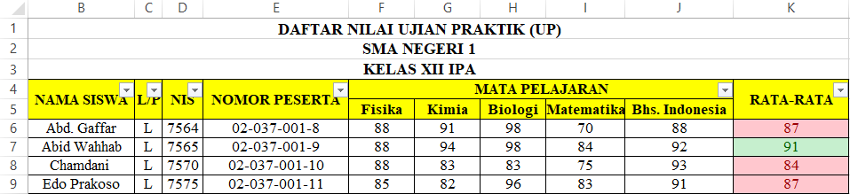

**Figure 2. 1 Sort and Filter Science Student Grades**

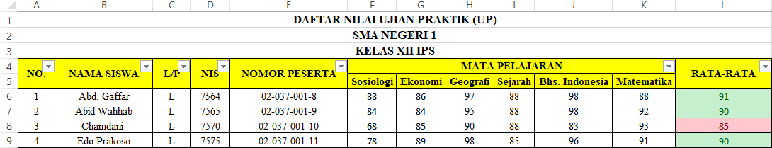

**Figure 2. 2 Sort and Filter Social Student Grades**

1. VLOOKUP

VLOOKUP stands for Vertical Lookup. VLOOKUP is a built-in Excel function that, as its name implies, enables you to find a specific number by looking for it vertically across the page (M, 2023). This function helps school in data management to increase efficiency and time saving.

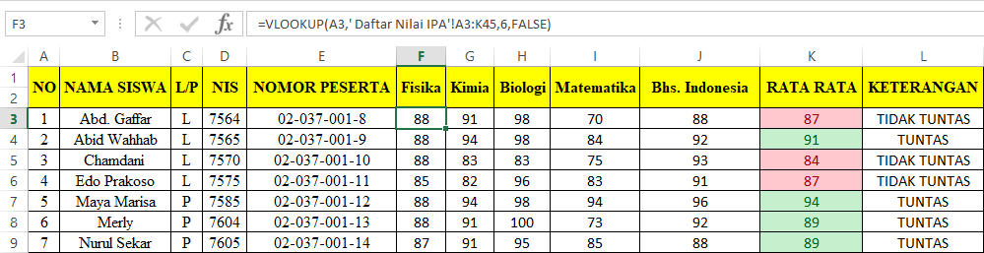

**Figure 2. 3 VLOOKUP Science Student Grades**

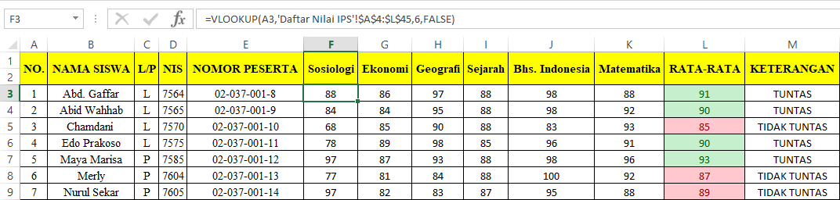

**Figure 2. 4 VLOOKUP Social Student Grade**

1. AVERAGE Function

The Excel AVERAGE function calculates the average (arithmetic mean) of supplied numbers. AVERAGE can handle up to 255 individual arguments, which can include numbers, cell references, ranges, arrays, and constants (Bruns, 2021). This function helps in calculating the average of each student grades.

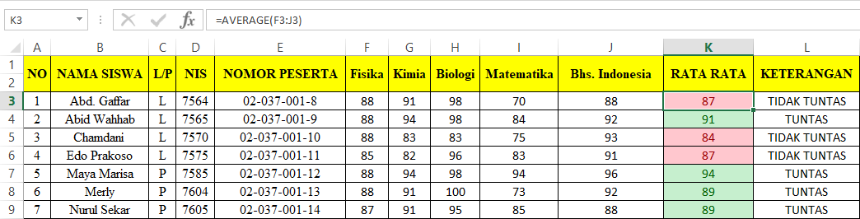

**Figure 2. 5 AVERAGE Function Science Student Grades**

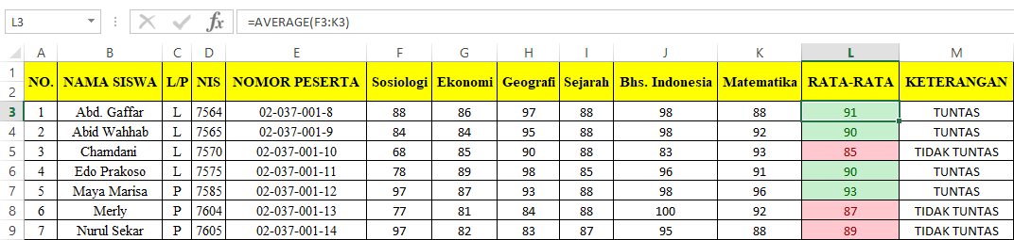

**Figure 2. 6 AVERAGE Function Social Student Grades**

1. IF Function

The Excel IF function runs a logical test and returns one value for a TRUE result, and another for a FALSE result (Bruns, IF Function, 2021). This function helps in determining whether a student grade is qualified to pass the test.

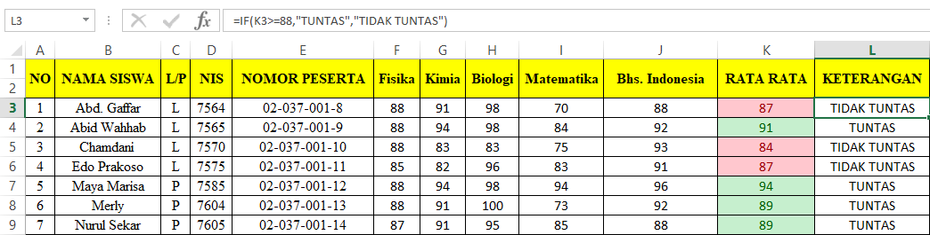

**Figure 2. 7 IF Function Science Student Grades**

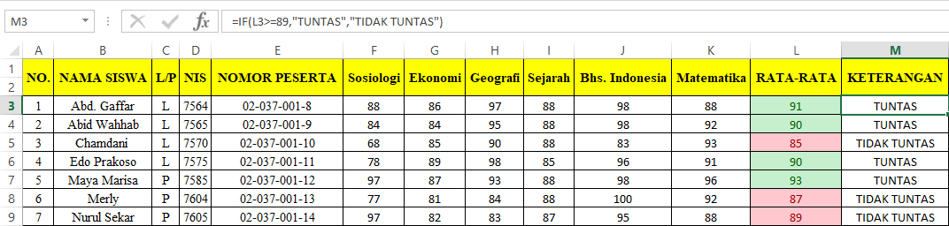

**Figure 2. 8 IF Function Social Student Grades**

1. Conditional Formatting

Conditional formatting is a feature that allows you to apply special formatting to cells that meet certain criteria. It is most often used to highlight, emphasize, or differentiate among data and information stored in a spreadsheet (Marker, 2022). This function helps in highlighting student grades that are below or above the passing grade.

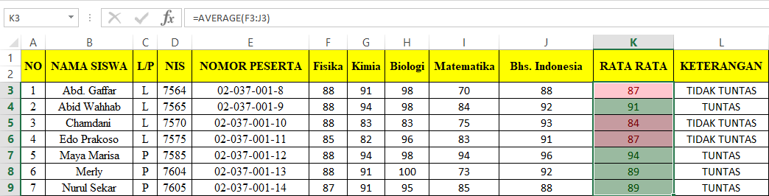

**Figure 2. 9 Conditional Formatting Science Student Grades**

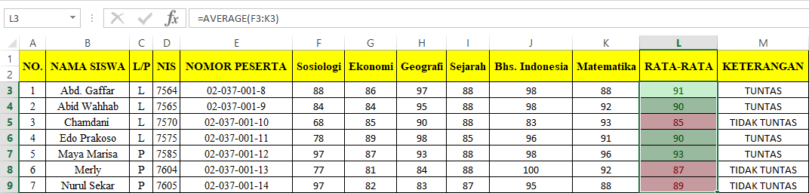

**Figure 2. 10 Conditional Formatting Social Student Grades**

1. PivotTable

A pivot table is a statistics tool that summarizes and reorganizes selected columns and rows of data in a [spreadsheet](https://www.techtarget.com/whatis/definition/spreadsheet) or database table to obtain a desired report (Lewis, 2022). Pivot table is used to rearrange and sum up student data.

**Table 2. 3 PivotTable Science Student Grades**

|  |  |  |  |  |  |
| --- | --- | --- | --- | --- | --- |
| NIS | (All) |  |  |  |  |
| L/P | L |  |  |  |  |
|  |  |  |  |  |  |
| **Row Labels** | **Average of Fisika** | **Average of Kimia** | **Average of Biologi** | **Average of Matematika** | **Average of Bhs. Indonesia** |
| Abd. Gaffar | 88 | 91 | 98 | 70 | 88 |
| Abib Muammar | 88 | 84 | 94 | 74 | 87 |
| Abid Wahhab | 88 | 94 | 98 | 84 | 92 |
| Alvin | 88 | 70 | 88 | 91 | 88 |
| Andi | 88 | 88 | 90 | 88 | 92 |
| Chamdani | 88 | 83 | 83 | 75 | 93 |
| David | 93 | 75 | 88 | 83 | 88 |
| Edo Prakoso | 85 | 82 | 96 | 83 | 91 |
| Fadhlah | 86 | 91 | 92 | 72 | 90 |
| Hidayat | 91 | 88 | 83 | 90 | 93 |
| Ilham | 92 | 73 | 93 | 91 | 88 |
| Ismatul | 80 | 77 | 79 | 72 | 83 |
| Ismaul | 88 | 63 | 96 | 91 | 90 |
| Iva | 90 | 72 | 92 | 91 | 86 |
| Khusnul | 93 | 88 | 86 | 87 | 87 |
| Nanto | 90 | 91 | 96 | 63 | 88 |
| Nugroho | 88 | 97 | 87 | 91 | 96 |
| Purwanto | 91 | 78 | 85 | 88 | 88 |
| Riski | 93 | 88 | 88 | 70 | 88 |
| **Grand Total** | **89** | **83** | **90** | **82** | **89** |

**Table 2. 4 PivotTable Social Student Grades**

|  |  |  |  |  |  |  |
| --- | --- | --- | --- | --- | --- | --- |
| NIS | (All) |  |  |  |  |  |
| L/P | L |  |  |  |  |  |
|  |  |  |  |  |  |  |
| **Row Labels** | **Average of Sosiologi** | **Average of Ekonomi** | **Average of Geografi** | **Average of Sejarah** | **Average of Bhs. Indonesia** | **Average of Matematika** |
| Abd. Gaffar | 88 | 86 | 97 | 88 | 98 | 88 |
| Abib Muammar | 93 | 95 | 96 | 88 | 94 | 87 |
| Abid Wahhab | 84 | 84 | 95 | 88 | 98 | 92 |
| Alvin | 94 | 96 | 88 | 88 | 88 | 88 |
| Andi | 83 | 83 | 91 | 88 | 90 | 92 |
| Chamdani | 68 | 85 | 90 | 88 | 83 | 93 |
| David | 95 | 91 | 85 | 93 | 88 | 88 |
| Edo Prakoso | 78 | 89 | 98 | 85 | 96 | 91 |
| Fadhlah | 98 | 96 | 94 | 86 | 92 | 90 |
| Hidayat | 88 | 95 | 88 | 91 | 83 | 93 |
| Ilham | 75 | 84 | 93 | 92 | 93 | 88 |
| Ismatul | 92 | 98 | 95 | 80 | 79 | 83 |
| Ismaul | 98 | 82 | 94 | 88 | 96 | 90 |
| Iva | 87 | 85 | 92 | 90 | 92 | 86 |
| Khusnul | 89 | 89 | 92 | 93 | 86 | 87 |
| Nanto | 99 | 95 | 90 | 90 | 96 | 88 |
| Nugroho | 85 | 89 | 92 | 88 | 87 | 96 |
| Purwanto | 96 | 97 | 80 | 91 | 85 | 88 |
| Riski | 84 | 98 | 86 | 93 | 88 | 88 |
| **Grand Total** | **88** | **90** | **91** | **89** | **90** | **89** |

1. PivotTable Chart

In Microsoft Excel, charts are used to make a graphical representation of any set of data. A chart is a visual representation of data, in which the data is represented by symbols such as bars in a bar chart or lines in a line chart (Excel Charts, 2022). The PivotTable chart is a visual representation of the data that are in the PivotTable.

**Figure 2. 11 PivotTable Chart Science Student Grades**

**Figure 2. 12 PivotTable Chart Social Student Grades**

# **CHAPTER III**

**CONCLUSION AND SUGGESTION**

## **III.1 Conclusion**

The advancement of information technology has remained consistent across time. The ability to minimize and save time is made possible by today's technological advancements, such as Microsoft Excel, which benefits both the teachers and the students in school. Excel also helps school in filtering and sorting data which helps in inputting data to the school.

## **III.2 Suggestion**

The suggestion that can be conveyed from this paper are:

1. Companies should be able to take use of larger technical improvements in order to raise company quality.
2. Data should be well structured and go through a thorough analysis.
3. Whether it is for a little report or a large report, the tool analysis for Excel should be used to organize data.
4. Laws that are current with the times are one example of the regulations that must be made by the government about the usage of technology.

**BIBLIOGRAPHY**

**Bruns, D. (2021).** *AVERAGE Function*. Retrieved from ExcelJet: https://exceljet.net/functions/average-function

**Bruns, D. (2021).** *IF Function*. Retrieved from ExcelJet: https://exceljet.net/functions/if-function

***Excel Charts*. (2022).** Retrieved from tutorialspoint: https://www.tutorialspoint.com/excel_charts/excel_charts_introduction.htm#:~:text=In%20Microsoft%20Excel%2C%20charts%20are,lines%20in%20a%20line%20chart.

**Lewis, S. (2022).** *Pivot Table*. Retrieved from TechTarget: https://www.techtarget.com/searchdatamanagement/definition/pivot-table

**M, S. (2023).** *How to use VLOOKUP in Excel*. Retrieved from simplilearn: https://www.simplilearn.com/tutorials/excel-tutorial/vlookup-in-excel#:~:text=in%20Excel%20is.-,What%20is%20VLOOKUP%20in%20Excel%3F,it%20vertically%20across%20the%20sheet.

**Marker, A. (2022).** *Comprehensive Tutorial for Excel Conditional Formatting*. Retrieved from smartsheet: https://www.smartsheet.com/how-to-apply-conditional-formatting-excel#:~:text=Conditional%20formatting%20is%20a%20feature,information%20stored%20in%20a%20spreadsheet.

***Sorting and Filtering Records*. (2022).** Retrieved from GCFGlobal: https://edu.gcfglobal.org/en/access2016/sorting-and-filtering-records/1/

**Team, C. (2022).** *Excel Definition*. Retrieved from CFI: https://corporatefinanceinstitute.com/resources/excel/excel-definition-overview/